 Is all American Food “junk food”?
Are you worried about your diet in the US?

  - Do you eat fast food because it’s cheap?
  - Are you having trouble finding nutritious food?
  - Do you have trouble understanding the labels on food packages?
  - Are you worried about gaining or losing too much weight?

Come learn how to improve your diet, and choose healthy foods.

NUTRITION WORKSHOP for INTERNATIONAL STUDENTS

When: Wednesday, October 28  Time: 2:30 – 4:00 PM  Where: Campus Center  Room 015  (Student Activity Center) | 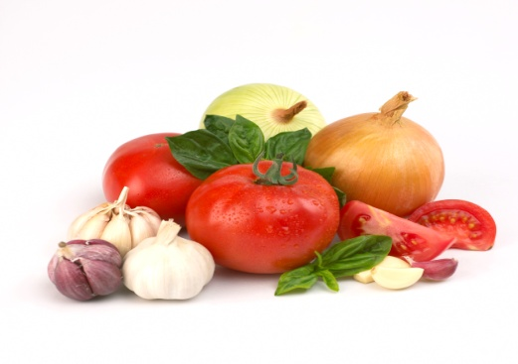

Sponsored by: Montgomery College, Rockville Hospitality Management, TC 220, (240) 567-5176
http://www.montgomerycollege.edu/Departments/hospitality/
And Rockville Counseling, Counseling and Advising Building, (240) 567-5063
http://www.montgomerycollege.edu/Departments/studevrv

For disability related accommodations call (240) 567-5058 or (301) 294-9672 (TTY)

Workshop Sign-up Form (Please Print Legibly)
(Keep the top portion of the form as a reminder and drop off the bottom part of the form in room 215, Counseling and Advising Building)

Name of Workshop: Nutrition for International Students

Name: ______________________________________________________________

E-mail: ______________________________________________________________

Phone: ____________________________________________________

